**KIHIHI MUSLIM SECONDARY SCHOOL**

**END OF FIRST TERM EXAMINATIONS 2024**

**INFORMATION AND COMMUNICATION TECHNOLOGY (ICT)**

**SENIOR ONE**

**TIME: 2HRS**

**NAME………………………………………………………………………………**

**INSTRUCTIONS:**

**Attempt all numbers**

1. Uganda Communications Commission is planning to construct an ICT resource center in Kabimu village. It has asked natives of the village to donate land where the center can be constructed. The members of the village have insisted to give out the land arguing that the project is useless to the community.

**Task**

As a student of ICT, write a report to the members of Kabimu village explaining to them the need for the ICT resource center.

**Support material**

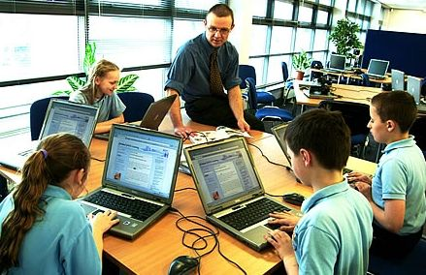

1. Uganda Bureau of Statistics (UBOS) is planning to hold a national census in Uganda very soon. The director of the organization is looking for competent personnel to work as enumerators during the census. Applicants for the post should submit their CVs to the office of UBOS not later than 12th April 2024.

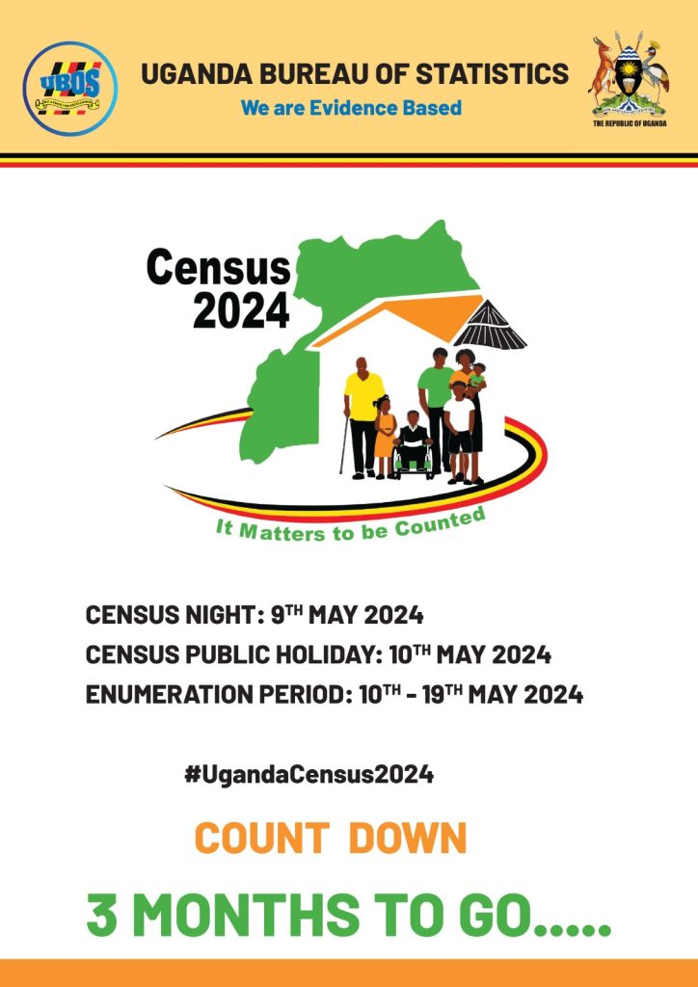

Jamilu is one of the interested applicants but unfortunately, he is unable to interpret the meaning of information as referred to in the above extract due to limited knowledge about ICT.

**Task**

Write a letter to Jamilu explaining to him the meaning of information and examples of information contained on a CV.

**“BEST WISHES”**